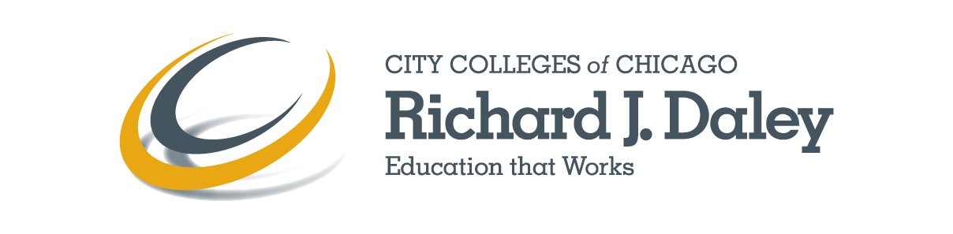

COURSE SYLLABUS

Semester: Spring Year: 2013

Mission Statement:
Richard J. Daley College provides high-quality education which leads to academic success, career development, and personal enrichment that fulfill diverse community needs.

Course (Discipline): Manufacturing Technology Number: 152 Section: IAI#: N/A

Course Title: Intermediate Welding Length of Course (Weeks): 16

Credit Hours: 3 Lecture Hours: 0 Lab Hours: 6 Contact Hours: 6

Meeting Day(s): Times: Building: AVI, 2800 S. Western Ave. Classroom #: 1111

Syllabus can be found on Blackboard website at https://ccc.blackboard.com/webapps/login/.

Dean, College to Careers in Advanced Manufacturing __Ray Prendergast_______

E-mail Address: rprendergast@ccc.edu Phone #: 773-838-7786

Address: 7500 South Pulaski Road Chicago, IL 60652

Office hours:

Course Description:
This is a second welding course that teaches basic welding skills that lead to an American Welding Society (AWS) qualification in Gas Tungsten Arc Welding (GTAW or TIG) and/or Shielded Metal Arc Welding (SMAW or stick). In addition to teaching the theory and practice of GTAW and SMAW welding processes, the course includes training in welding with a FANUC robot, resistance welding and torch work.

Course Prerequisites:
Grade of C or better in 340MFGT 151, or Consent of Department Chairperson.

Students Course is Expected to Serve:
This course is intended to serve students who are interested in careers in manufacturing technology, engineering, or construction.

Course Objectives: Upon completion of this course students will:
- Explain the main types of welding processes: Gas Metal Arc Welding (GMAW), Gas Tungsten Arc Welding (GTAW), Shielded Metal Arc Welding (SMAW), Resistance Welding (RW), and robotic welding.
- Illustrate the differences among the various types of welding processes.
- Deliver basic knowledge of the different materials that can be and are most commonly welded.
- Demonstrate the skills needed to weld steel plate to American Welding Society specifications.

Student Learning Outcomes:
Completers of this course will be able to:
- Compare and contrast the main types of welding processes according to equipment used, procedures and materials that can be welded.
- Set-up and operate GTAW, SMAW, resistance welding, and Robotic welding machines.
- Prepare and organize the equipment, materials, and work area for welding.
- Produce acceptable welds using GTAW, SMAW and resistance welding processes.
- Weld a sample using steel plate to AWS D1.1 specifications, using the GTAW (TIG) process.
- Program and operate a robotic welder to join thin steel plate using the GMAW (MIG) process.

Recommended Texts and Course Materials:
Cary, H.B., and Helzer, S.C. (2004). Modern Welding Technology, 6th Edition. New York, NY: Prentice-Hal, a division of Pearson Education. ISBN13: 978-0131130296.

Additional Course Requirements:
N/A

Recommended Methods of Instruction: Lecture, shop work including layout, cutting metal, and welding. Class projects will include welding a sample that could be used to earn an AWS qualification.

Recommended Methods of Evaluation:
Student learning will be assessed using written exams and practical shop projects that include material preparation and welding according to American Welding Society standards.

Midterm and final course grades will be based on the following assessments:
Attendance
Homework
Shop work
Written tests
Welding test (hands on)

Grading Scale:
90-100% = A
80-89 = B
70-79 = C
60-69 = D
Below 60 = F

See the Policy on grade designations and grade appeals at:
http://www.ccc.edu/colleges/daley/departments/Pages/Grade-Appeal-Policy-and-Procedure.aspx

NOTE: Type or copy and paste the link above into a web browser to view its content.

Topical Outline / Course Calendar:
Week 1 – course intro lab – intro to SMAW machines
Week 2 – personal and shop safety lab – SMAW training
Week 3 – SMAW principles lab – intro to class project
Week 4 - SMAW equipment lab – SMAW training
Week 5 – SMAW electrodes lab - SMAW training
Week 6 – Gas soldering and brazing intro lab – torch work
Week 7 – Gas torch principles lab – torch work
Week 8 – Midterm review midterm
Week 9 – GTAW principles lab – TIG
Week 9 – GTAW equipment lab – TIG
Week 10 – GTAW equipment lab – TIG
Week 11 – GTAW lab lab – TIG
Week 12 – Resistance Welding (RW) lab – RW
Week 13 – Robotic Welding intro lab – robot training
Week 14 – Robotic equipment lab – robot training
Week 15 – Robotic equipment lab – robot training
Week 16 – course review final

This workforce solution was funded by a grant awarded by the U.S. Department of Labor’s Employment and Training Administration. The solution was created by the grantee and does not necessarily reflect the official position of the U.S. Department of Labor. The Department of Labor makes no guarantees, warranties, or assurances of any kind, express or implied, with respect to such information, including any information on linked sites and including, but not limited to, accuracy of the information or its completeness, timelines, usefulness, adequacy, continued availability, or ownership. This solution is copyrighted by the institution that created it. Internal use, by an organization and/or personal use by an individual for non-commercial purposes, is permissible. All other uses require the prior authorization of the copyright holder.

